B&K GREEN FUTURES.
HOME ABOUT-US PRODUCTS SERVICES CONTACTS GALLERY
Welcome message
We welcome you to b&k green futures, a company that grows practical solutions for a cleaner Kampala.
SHORT INTRODUTION
B&K green futures is a community-based NGO connecting young people, households to environmental actions and skills.
TEL; +256780169571.
Email: info@b&k.ug.org

ORGANISATIOLN BACKGROUND
FOR-MORE CONTACT-US
B&k futures was founded as a community initiative in 2003 and later funded by the government of Uganda in 2011. It s tarted with an aim of collecting disposables but later discovered that the disposables can be recycled and made useful again.
MISSION: Making a cleaner community and turn everyday environmental challenges into practical opportunities.
VISION: To become the leading company in connecting young people to environmental actions and inclusive live hoods.

OUR SERVICES
ECO-SKILLS TRAINING
Works on recycling and urban gardening.
WASTE & RECYCLING
Sorting education and links to recycling partners.
SCHOOL ECO-CLUBS
Interactive projects that help students lead environmental projects.

images
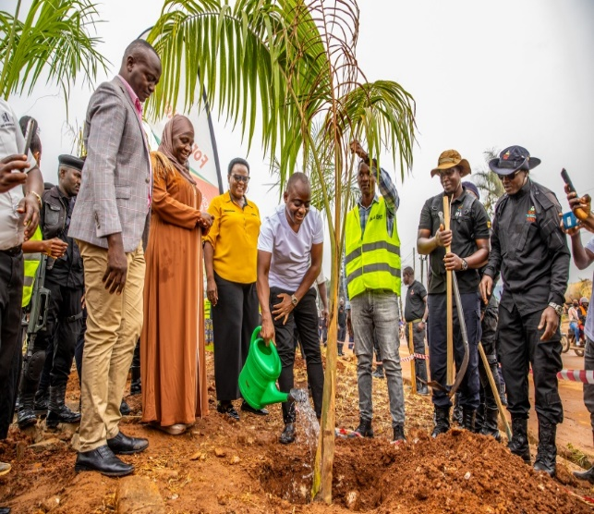
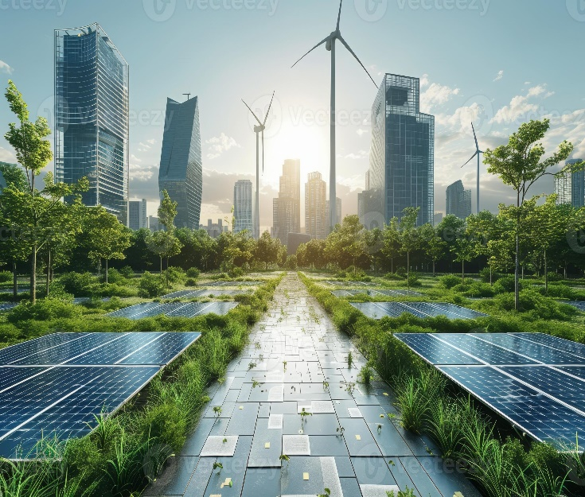
figure 2 tree planting
Figure 1greener environment

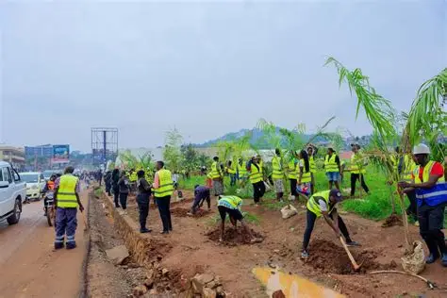
figure 3 school eco-club

CONTACT US
Address: P.0 Box 555, Kampala, Uganda
Telephone: +256780169771
Email: info@b&k.ug.org
Time: Mon-Fri,8:30-5:00pm

SEND US A MESSAGE
FULLNAME: ----------------------------------------
EMAIL: -----------------------------------------------------
MESSAGE: ----------------------------------------------

WEBSITE SITEMAP
HOME

ABOUT US

SERVICES

GALLERY

CONTACT US

